Task 1: Configure Classic Load Balancer (CLB)
Objective
Understand the legacy AWS load balancer and distribute traffic across multiple EC2 instances.
Why Are We Doing This?
- Learn Layer 4 and Layer 7 load balancing basics.
- Understand health checks.
- Improve application availability.
Outcome
Users access one DNS name, and traffic is distributed to healthy EC2 instances.
Prerequisites
- AWS Account
- VPC available
- Minimum 2 EC2 instances running
- Security Group allowing:
  - HTTP (80)
  - SSH (22)
Example:
Instance | Private IP
Web1 | 10.0.1.10
Web2 | 10.0.2.10
Both should have Apache/Nginx installed.
Validation Before Starting
sudo systemctl status nginx
or
sudo systemctl status httpd
Access:
http://EC2-Public-IP
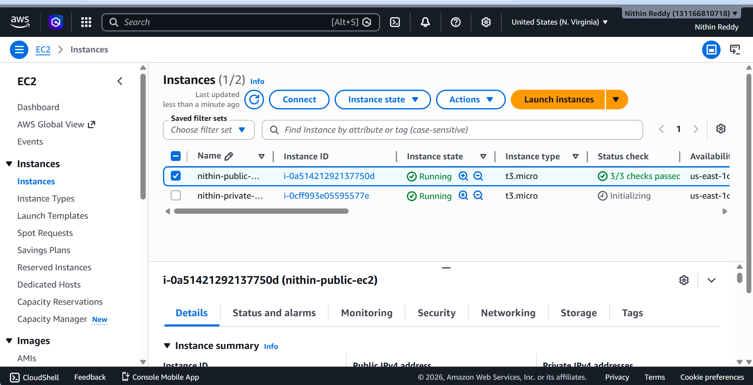
Implementation Steps
Step 1: Open Load Balancers
AWS Console
EC2
→ Load Balancers
→ Create Load Balancer
→ Classic Load Balancer

Step 2: Configure
Name:
classic-lb
Listener:
HTTP 80 → HTTP 80
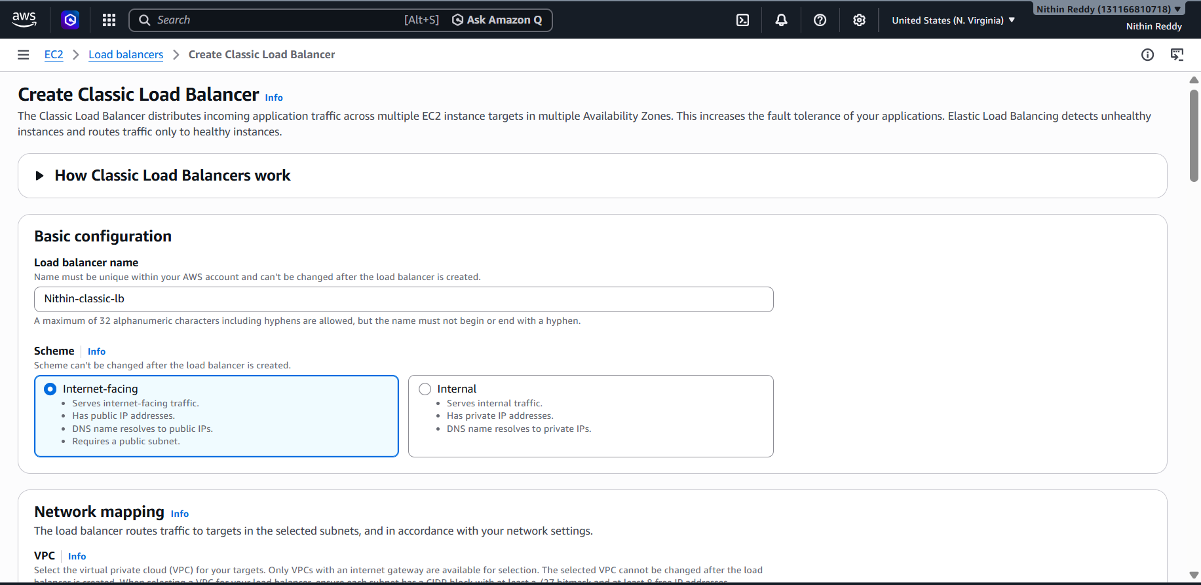
Step 3: Select VPC
Choose:
Default VPC
or training VPC.
Select at least 2 subnets.
Step 4: Configure Health Check
Ping Protocol: HTTP
Ping Port: 80
Ping Path: /
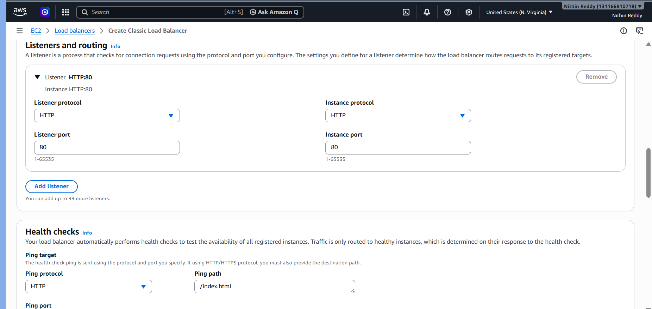
Step 5: Register Instances
Select:
Web1
Web2
Step 6: Create
Wait 2–3 minutes.
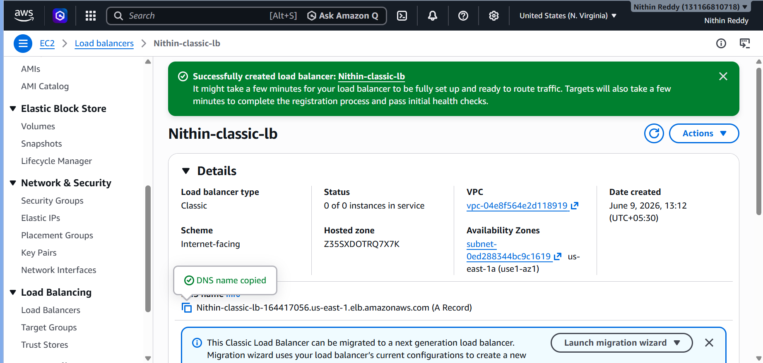

Validation
Copy CLB DNS.
Example:
classic-lb-123456.us-east-1.elb.amazonaws.com
Open browser:
http://CLB-DNS
Refresh multiple times.
Traffic should hit healthy servers.


Common Errors
OutOfService
Cause:
- Web server stopped
Fix:
sudo systemctl start nginx

Task 2: Configure Application Load Balancer (ALB)
Objective
Create modern Layer-7 load balancing.
Why?
ALB supports:
- Host based routing
- Path based routing
- SSL termination
- Better monitoring

Outcome
Application receives traffic through ALB DNS.

Prerequisites
- 2 EC2 instances
- Same VPC
- HTTP running

Implementation
Step 1
EC2
→ Load Balancers
→ Create Load Balancer
→ Application Load Balancer
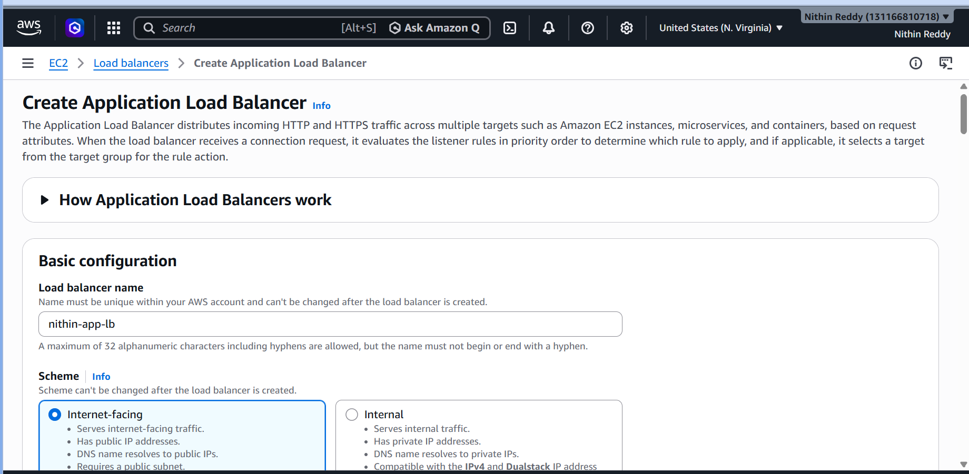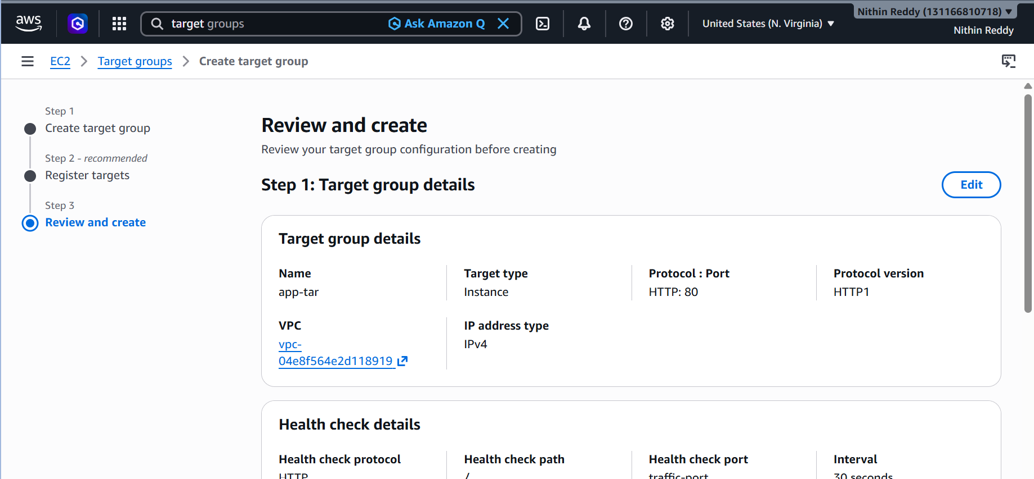
Step 2
Name:
app-alb
Scheme:
Internet-facing
IP Type:
IPv4
Step 3
Select
2 Public Subnets
Step 4
Security Group
Allow:
HTTP 80
HTTPS 443
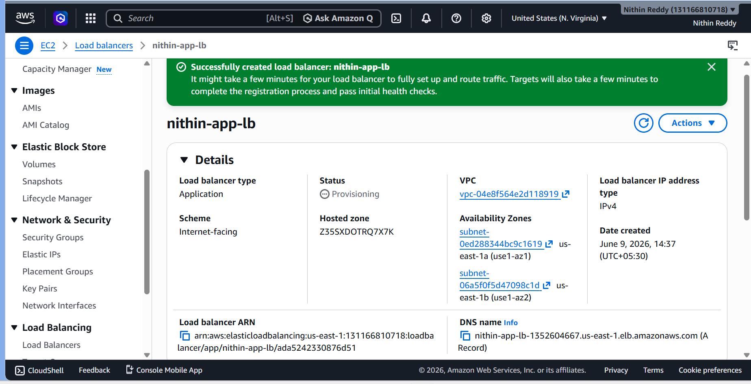
Step 5
Create Target Group
Target Type: Instances
Protocol: HTTP
Port: 80
Register:
Web1
Web2
Step 6
Attach Target Group
Create ALB.
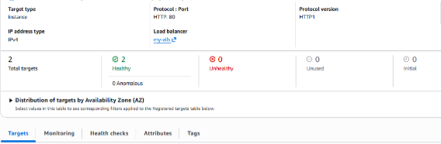
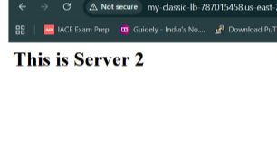
Troubleshooting
Targets Unhealthy
Check:
curl localhost

Task 3: Configure Network Load Balancer (NLB)
Objective
Create a Network Load Balancer and distribute traffic to EC2 instances.

Why Are We Doing This?
To learn:
- Layer 4 Load Balancing
- TCP traffic forwarding
- High-performance load balancing
- AWS NLB architecture

Outcome
User
↓
Network Load Balancer
↓
Web1 (Nginx)
Web2 (Nginx)
Users access the NLB DNS and traffic is forwarded to healthy servers.

Prerequisites
Reuse Existing Instances
Do NOT create new EC2s.
Use:
Web1
Web2
used in Task 1 and Task 2.

Verify Nginx
SSH into both servers.
Run:
sudo systemctl status nginx
Expected:
active (running)

Verify Security Group
Inbound Rules:
Type | Port | Source
SSH | 22 | My IP
HTTP | 80 | 0.0.0.0/0

Step 1: Create Target Group
Go to:
EC2
→ Target Groups
→ Create Target Group
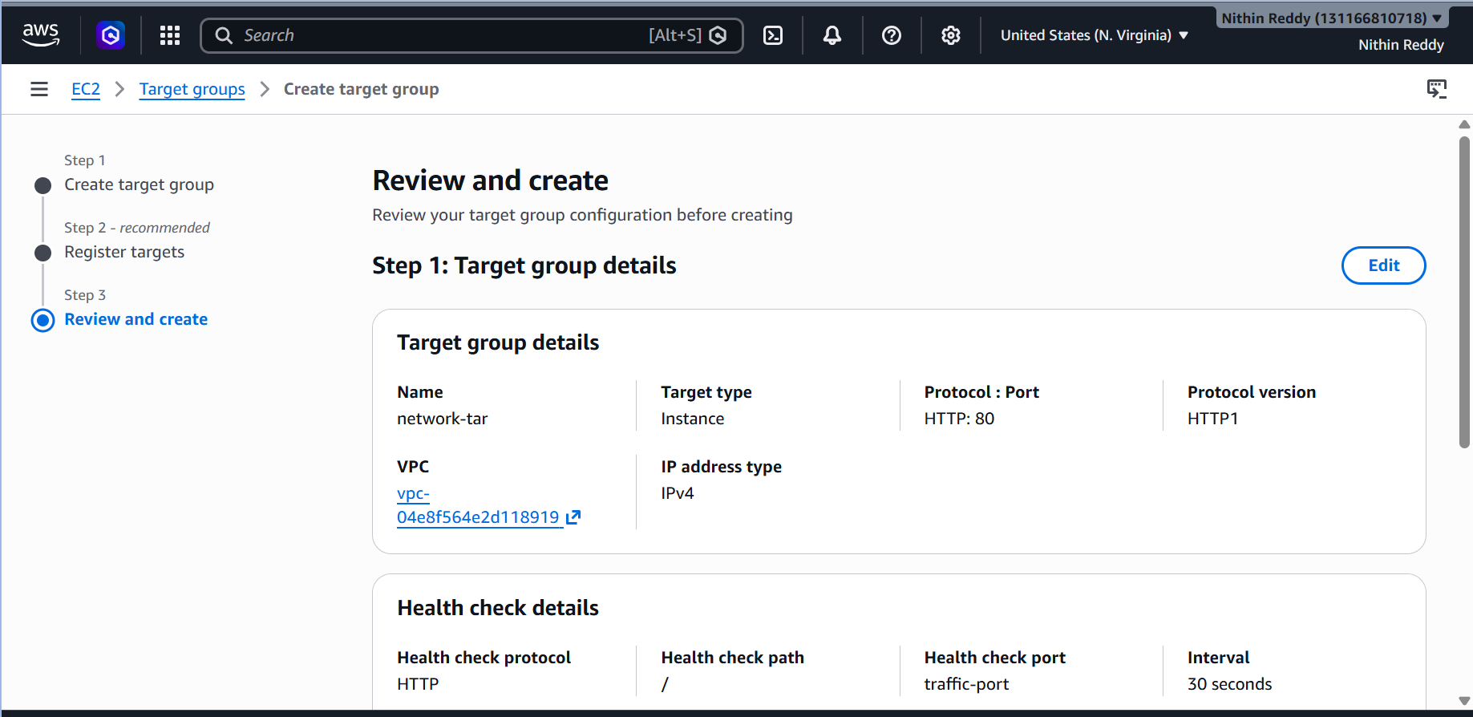
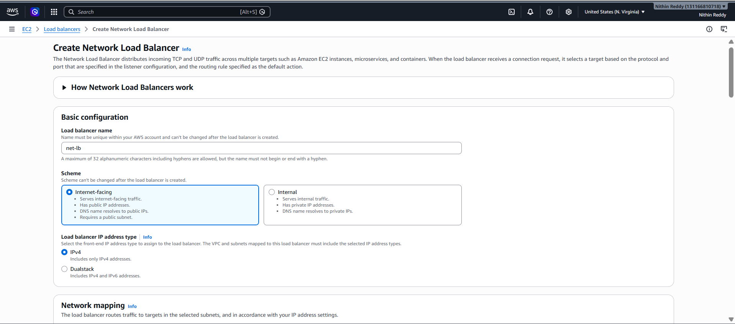
Basic Configuration
Choose:
Target Type = Instances
Protocol:
TCP
Port:
80
Name:
nithin-nlb-tg
VPC:
Default VPC
Click:
Next

Step 2: Register Targets
Select:
Web1
Web2
Click:
Include as pending below
Then:
Create Target Group

Step 3: Create Network Load Balancer
Go to:
EC2
→ Load Balancers
→ Create Load Balancer
→ Network Load Balancer
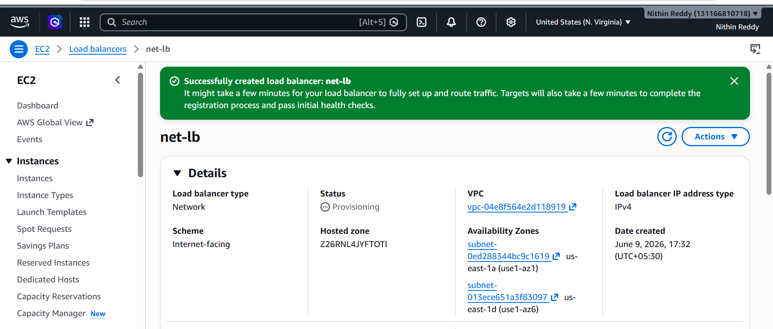
Configure NLB
Name
nithin-network-lb
Scheme
Internet-facing
IP Type
IPv4

Step 4: Select Network
Choose:
Default VPC
Select at least:
Subnet 1
Subnet 2
Two Availability Zones are recommended.
Example:
us-east-1a
us-east-1b

Step 5: Configure Listener
Listener:
TCP
Port:
80
Forward to:
nithin-nlb-tg

Step 6: Create Load Balancer
Click:
Create Load Balancer
Wait:
2–5 minutes
for provisioning.

Step 7: Verify Target Health
Go to:
Target Groups
→ nithin-nlb-tg
→ Targets
Expected:
Healthy
Healthy
Both instances should show healthy.
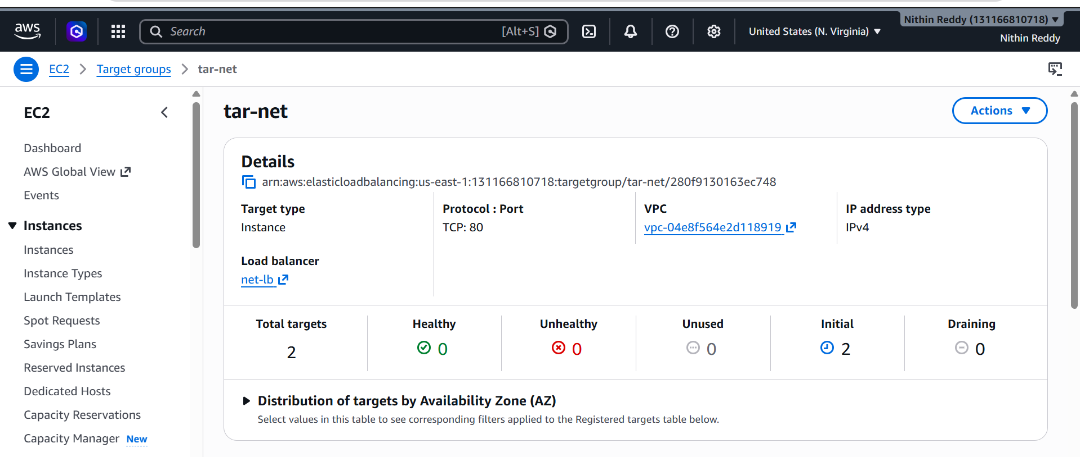
Validation
Copy NLB DNS.
Example:
nithin-network-lb-xxxxxxxx.elb.amazonaws.com
Open:
http://NLB-DNS
Expected:
Web Server 1
or
Web Server 2
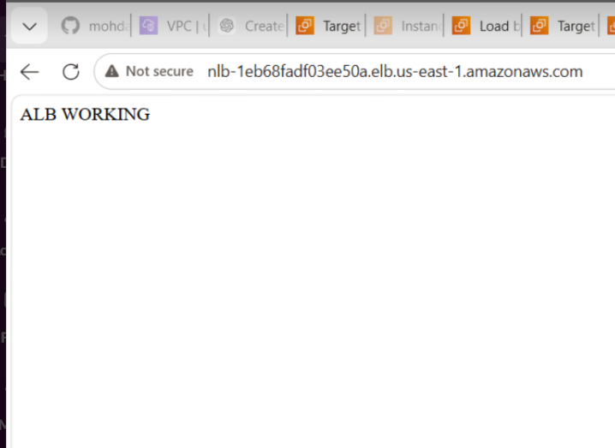
Validation Commands
SSH into server:
curl localhost
Expected:
<h1>Web Server 1</h1>
or
<h1>Web Server 2</h1>
Common Errors
Error: Target Unhealthy
Nginx stopped
Task 4: Attach SSL to ALB
Objective
Enable HTTPS access to your application.
Before:
http://your-alb-dns
After:
https://yourdomain.com

Architecture
Internet
↓
HTTPS 443
↓
ALB
↓
HTTP 80
↓
EC2 Instances
SSL terminates at ALB.

Step 1: Request ACM Certificate
Go to:
AWS Console
→ Certificate Manager (ACM)
→ Request Certificate
Choose:
Request a public certificate

Step 2: Add Domain
Example:
nithinreddy.xyz
or
www.nithinreddy.xyz
You can also add:
*.nithinreddy.xyz
for wildcard.
Click:
Next
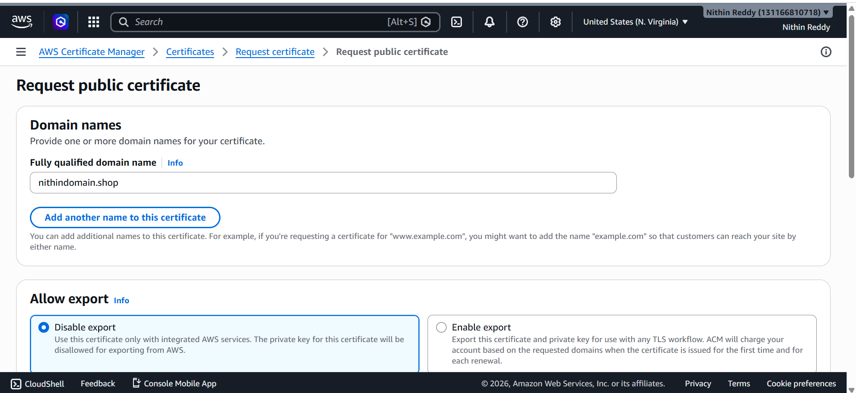
Step 3: Validation Method
Select:
DNS Validation
Click:
Request

Step 4: Create Validation Record
ACM generates a CNAME.
Example:
Name:
_abcd1234.domain.com
Value:
_xyz.acm-validations.aws
Click:
Create records in Route53
(if using Route53)

Step 5: Wait for Certificate
Status:
Pending Validation
After a few minutes:
Issued
Do not continue until:
Issued
appears.
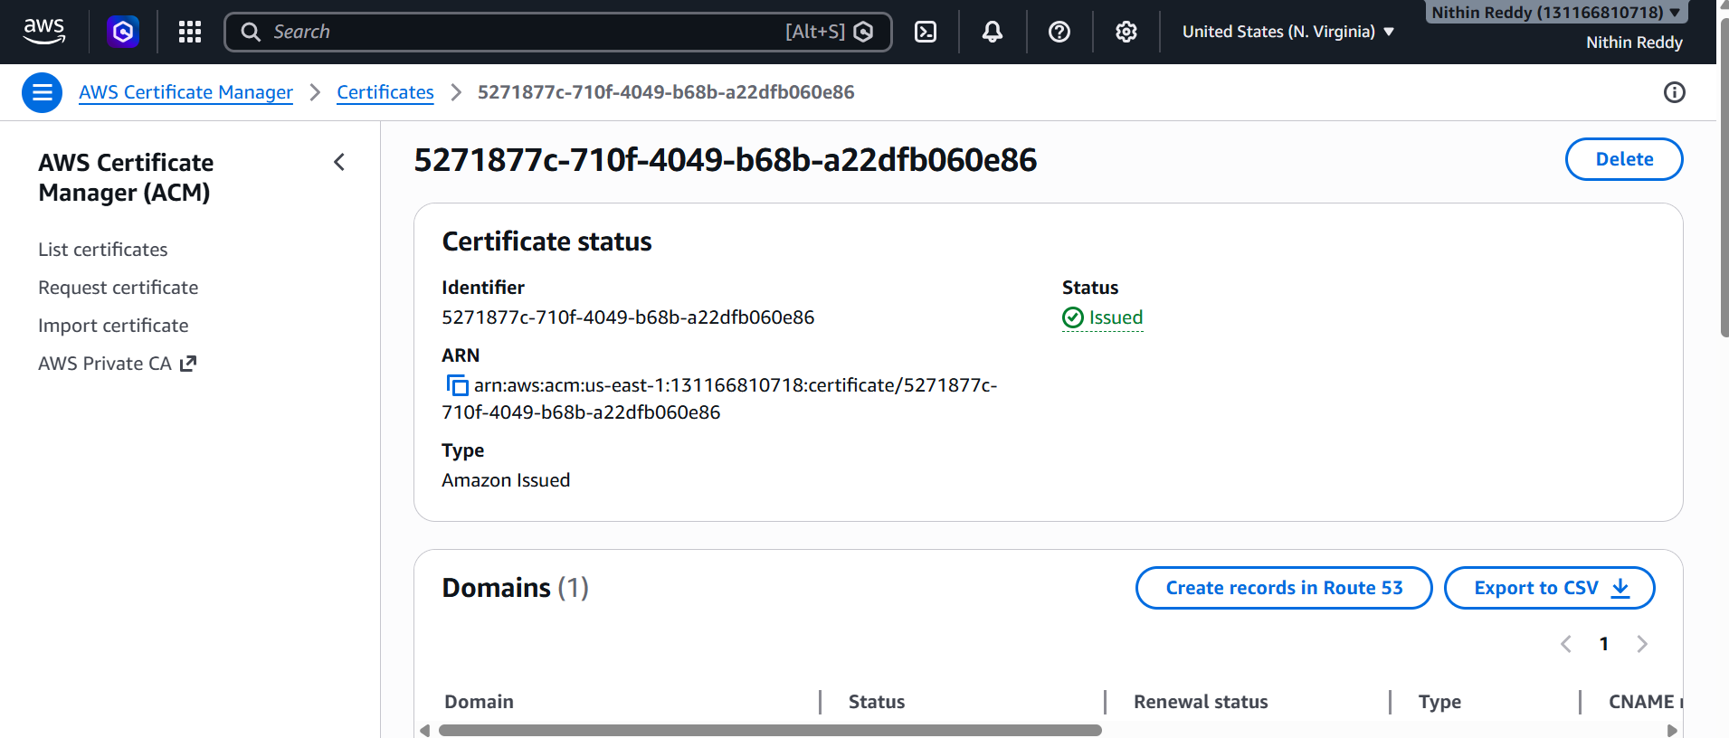
Step 6: Add HTTPS Listener
Go to:
EC2
→ Load Balancers
→ Your ALB
→ Listeners and Rules
Click:
Add Listener
Configure:
Protocol: HTTPS
Port: 443

Step 7: Select Certificate
Choose:
From ACM
Select your certificate.
Example:
nithinreddy.xyz

Step 8: Forward Traffic
Default Action:
Forward to
ALB Target Group
Example:
nithin-alb-tg
Save.

Step 9: Redirect HTTP → HTTPS (Recommended)
Open:
ALB
→ HTTP Listener (80)
Edit rule.
Choose:
Redirect to HTTPS
Configure:
Protocol: HTTPS
Port: 443
Status Code: 301
Save.
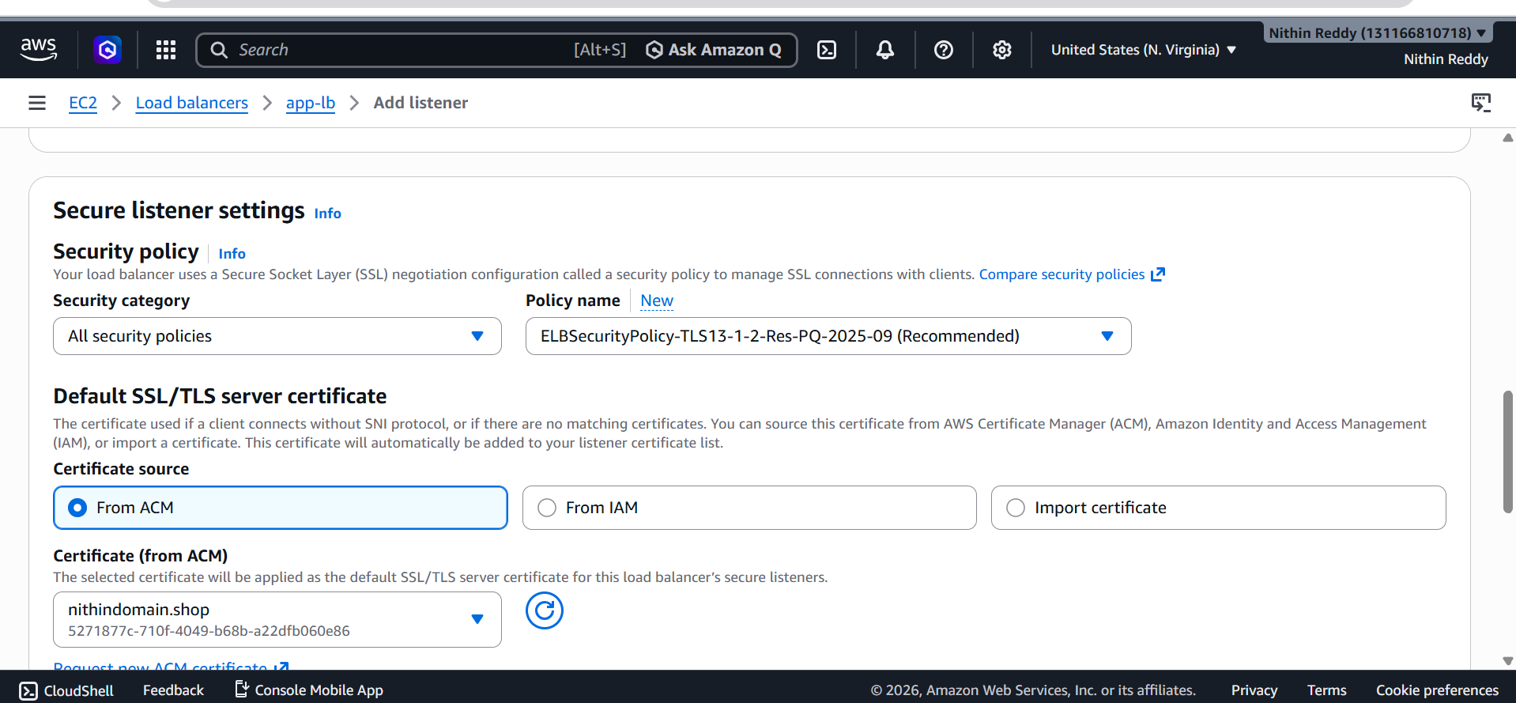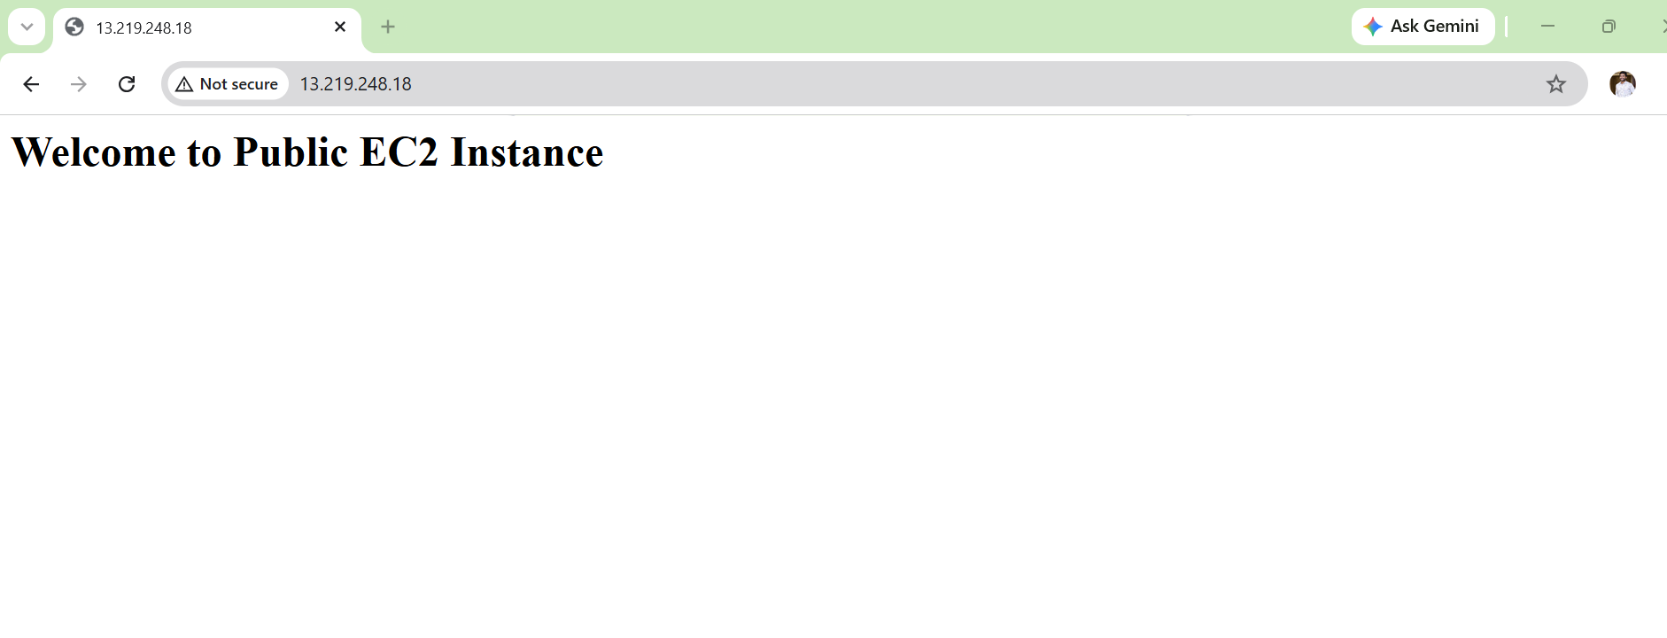
Validation
Open:
https://yourdomain.com
Expected:
✅ Page loads
✅ Browser lock icon appears

Common Errors
Certificate Stuck in Pending Validation
Cause:
DNS record missing
Fix:
Route53 Hosted Zone
→ Verify CNAME record exists

Task 5: Map Application Load Balancer to Route53
Objective
Instead of accessing:
http://nithin-app-lb-xxxxxxxx.us-east-1.elb.amazonaws.com
access:
https://yourdomain.com
or
https://www.yourdomain.com

Prerequisites
You should already have:
✅ Domain name
✅ Route53 Hosted Zone
✅ Application Load Balancer
✅ ACM Certificate Issued

Step 1: Get ALB DNS Name
Go to:
EC2
→ Load Balancers
→ nithin-app-lb
Copy:
DNS Name
Example:
nithin-app-lb-1352604667.us-east-1.elb.amazonaws.com

Step 2: Open Route53
Go to:
Route53
→ Hosted Zones
→ Your Domain
Example:
yourdomain.com

Step 3: Create Record
Click:
Create Record

Step 4: Configure Record
If Root Domain
Example:
yourdomain.com
Leave Record Name blank.

Record Type
A

Alias
Enable:
Alias = ON

Route Traffic To
Choose:
Alias to Application and Classic Load Balancer

Region
us-east-1

Select Load Balancer
Choose:
nithin-app-lb
Save.

Step 5: Create WWW Record (Optional)
Create another record.
Name:
www
Type:
A
Alias:
Yes
Target:
Same ALB
Save.
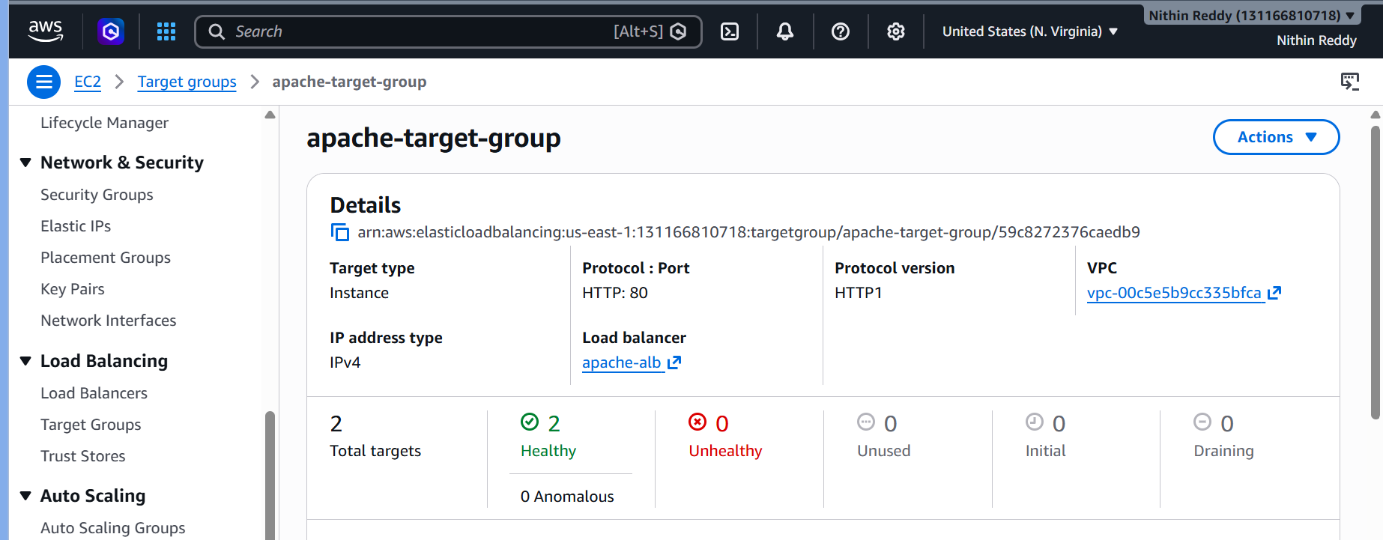
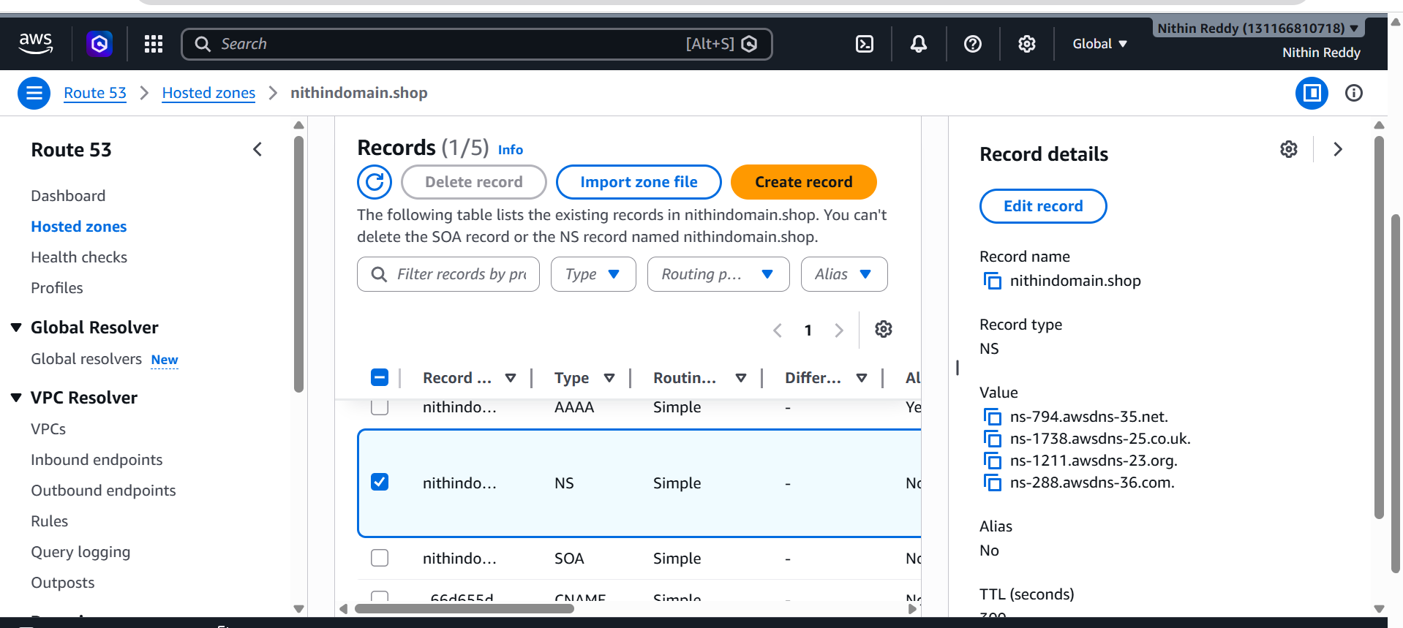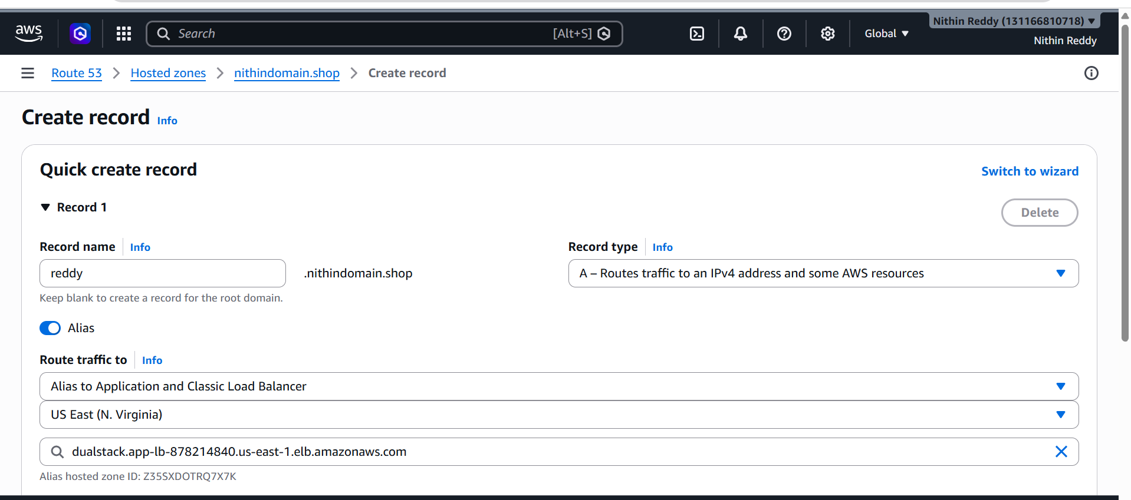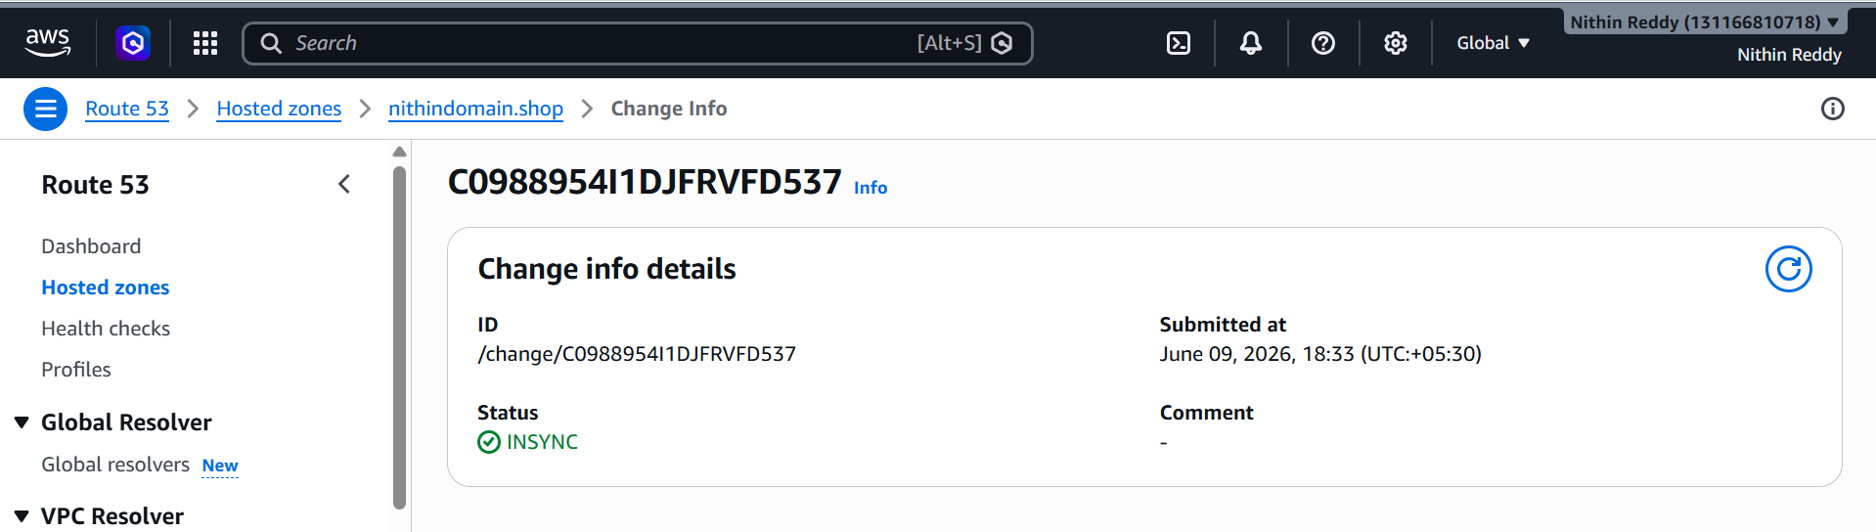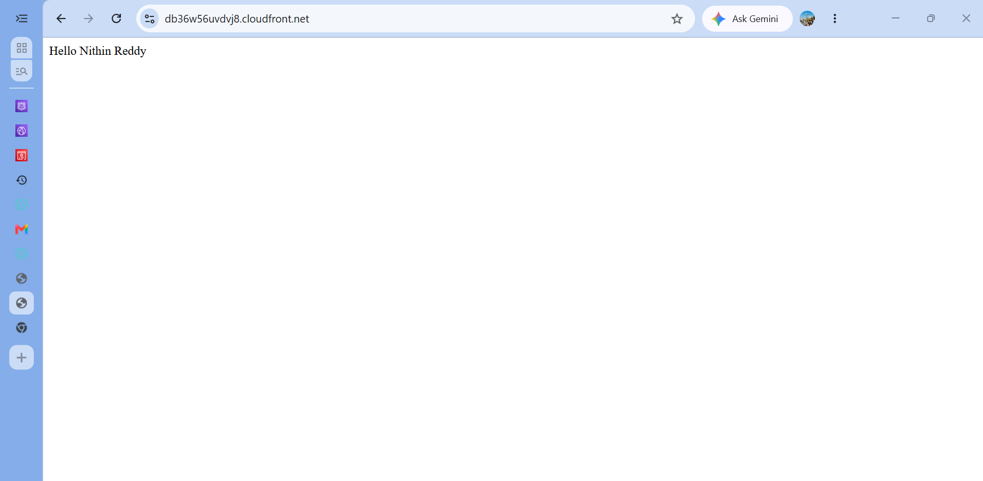
Validation
Run:
nslookup yourdomain.com
Expected:
Name: yourdomain.com
Address: ALB IP

Open:
https://yourdomain.com
Expected:
✅ Lock icon
✅ Website loads
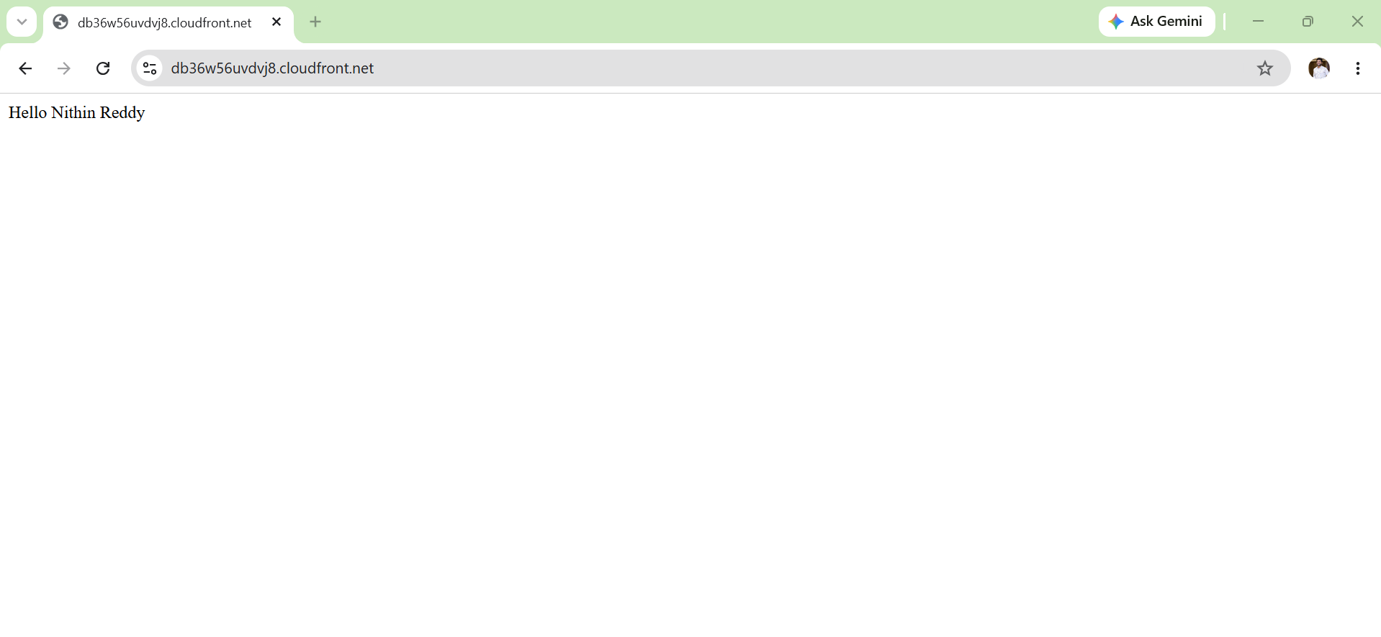
Common Errors
Domain Not Loading
Check:
Hosted Zone Nameservers
must match domain registrar nameservers.

Task 6: Push Application Load Balancer Logs to S3
Objective
Store all ALB access logs in an S3 bucket.
Why?
- Monitor traffic
- Troubleshoot issues
- Security auditing
- Track client requests
Architecture
Users
↓
Application Load Balancer
↓
S3 Bucket
(ALB Logs)

Prerequisites
You should already have:
✅ Application Load Balancer
✅ Target Group Healthy
✅ EC2 Instances Running
✅ Route53 Working

Step 1: Create S3 Bucket
Go to:
S3
→ Create Bucket
Bucket Name:
nithin-alb-logs-2026
(Use a unique name if already taken.)
Region:
US East (N. Virginia)
Keep defaults.
Click:
Create Bucket
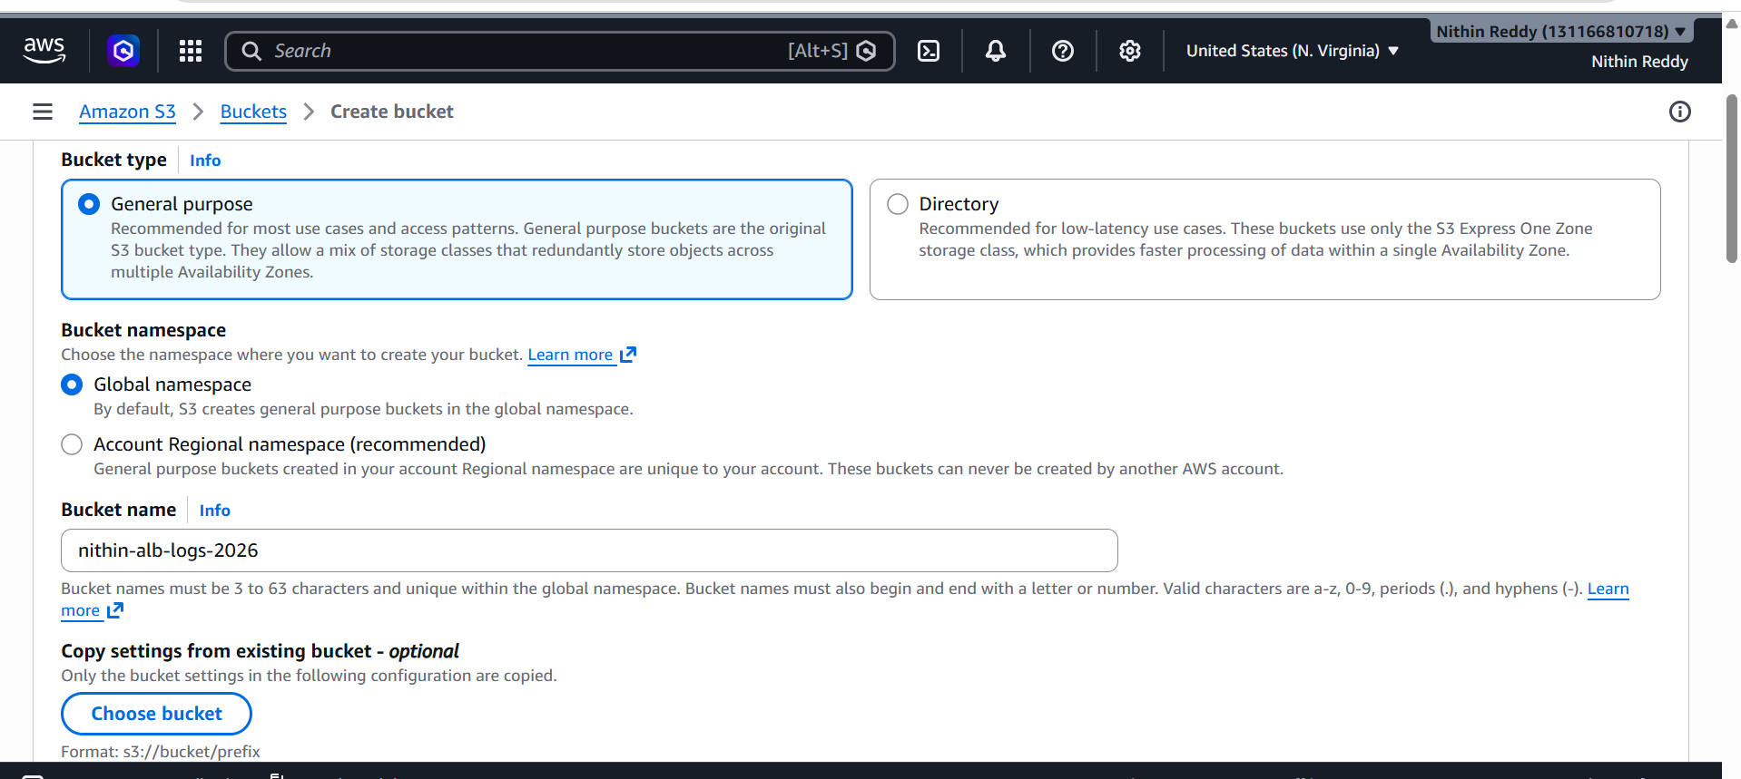
Step 2: Get AWS Account ID
Go to:
Top Right Account Menu
→ Account
Copy:
12-digit Account ID
Example:
123456789012

Step 3: Add Bucket Policy
Open:
S3
→ Bucket
→ Permissions
→ Bucket Policy
Paste:
{
"Version": "2012-10-17",
"Statement": [
{
"Sid": "AWSLogDeliveryWrite",
"Effect": "Allow",
"Principal": {
"Service": "logdelivery.elasticloadbalancing.amazonaws.com"
},
"Action": "s3:PutObject",
"Resource": "arn:aws:s3:::nithin-alb-logs-2026/AWSLogs/YOUR-ACCOUNT-ID/*"
}
]
}
Replace:
YOUR-ACCOUNT-ID
with your actual AWS account ID.
Save.
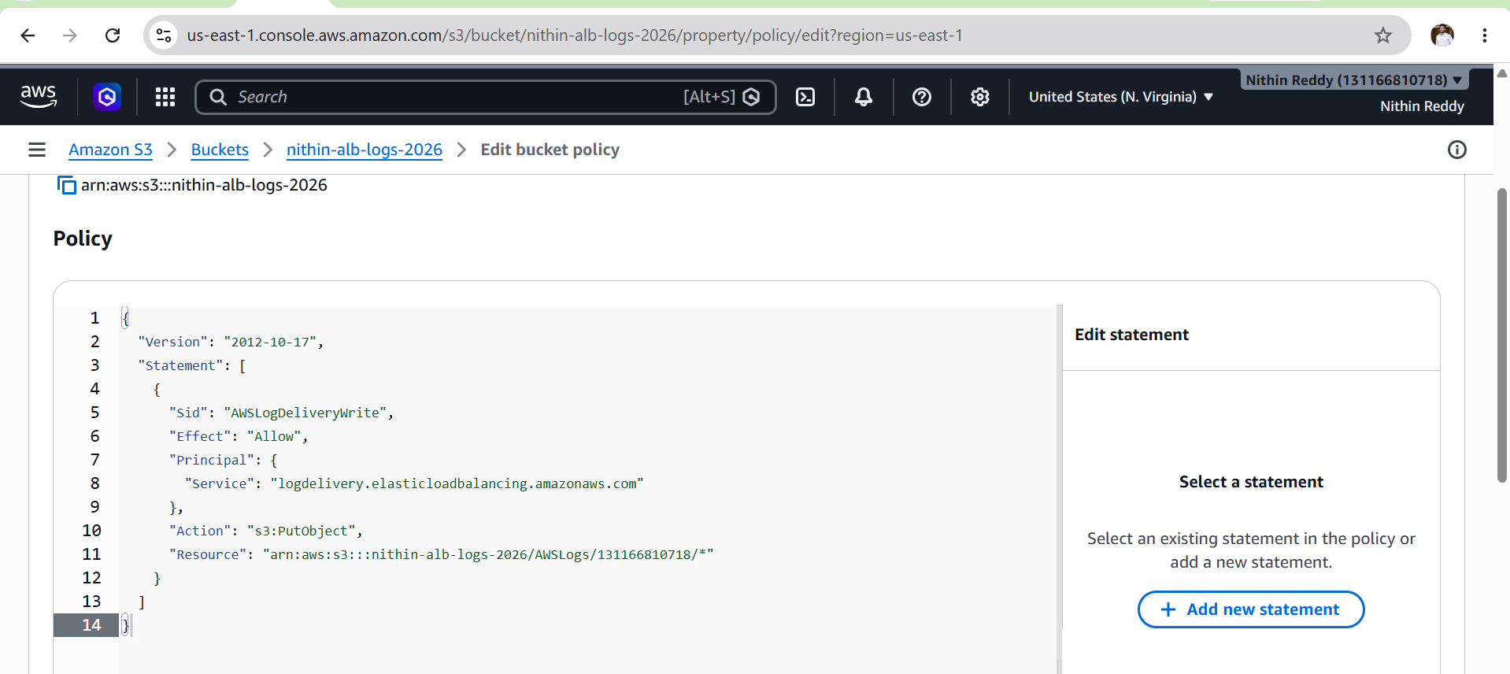
Step 4: Enable Access Logs on ALB
Go to:
EC2
→ Load Balancers
→ nithin-app-lb
Select:
Attributes
Click:
Edit Attributes

Enable:
Access Logs = ON
Bucket:
nithin-alb-logs-2026
Prefix:
alb
Save.
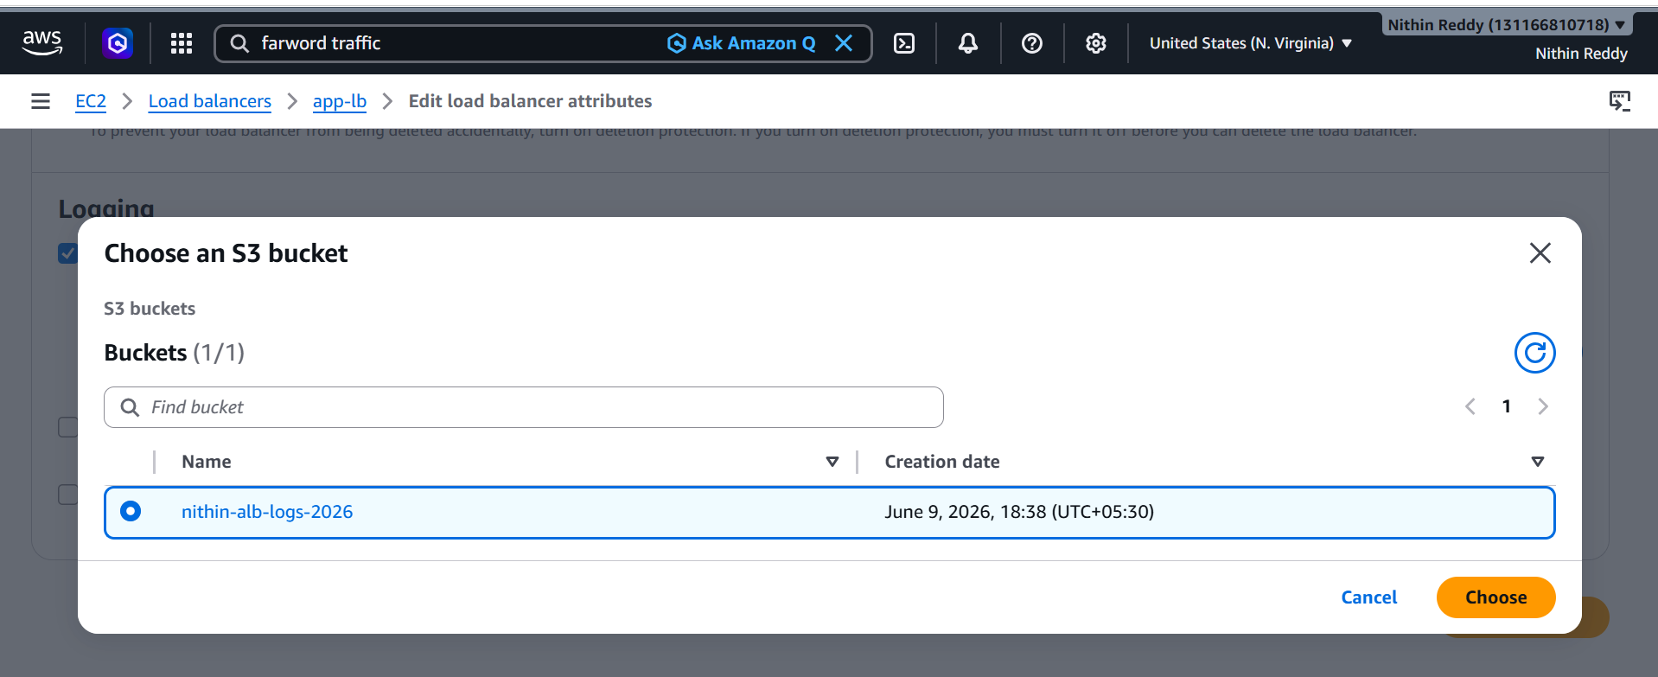
Step 5: Generate Traffic
Open your application:
https://yourdomain.com
or
http://ALB-DNS
Refresh:
10–20 times
This creates log entries.

Step 6: Verify Logs
Go to:
S3
→ nithin-alb-logs-2026
Open:
alb
Then:
AWSLogs
Expected:
AWSLogs/
└── Account-ID/
└── elasticloadbalancing/
└── us-east-1/
└── log-files
You should see .log.gz files.
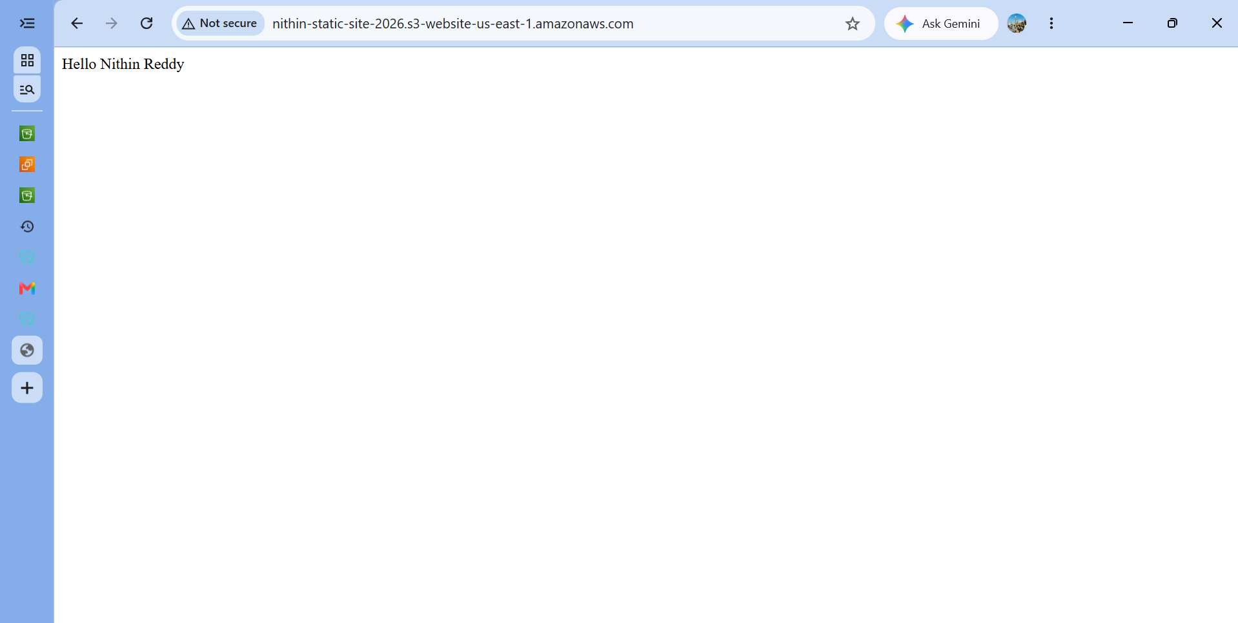
Validation Screenshot Checklist
Take screenshots of:
✅ S3 Bucket Created
✅ Bucket Policy
✅ ALB Attributes (Access Logs Enabled)
✅ S3 Log Files Present
✅ ALB Working Through Domain

Common Errors
Access Denied
Cause:
Wrong Bucket Policy
Fix:
- Verify bucket name
- Verify account ID
- Save policy again

